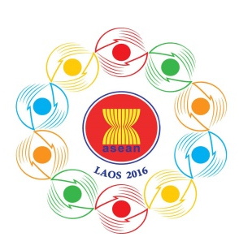
Turning Vision into Reality

for a Dynamic ASEAN Community
Laos 2016
‘Promoting Defence Cooperation for a Dynamic ASEAN Community’

ADSOM-Plus
Vientiane, Lao PDR, 23-25 April 2016

Bilateral Meeting Form
Country:

We request to have bilateral meetings with:
1. | 10.
2. | 11.
3. | 12.
4. | 13.
5. | 14.
6. | 15.
7. | 16.
8. | 17
9. | 18.

Kindly submit the completed registration form by 25 March 2016,
Either by fax or e-mail to the following contact:

10th ADMM Secretariat
Tel: + (856 21) 911727
Fax: + (856 21) 911728
Email: admm2016laos@yahoo.com
- Capt. Maneelath Vongpakaiphet
Mob: + (856 20) 2248 2345
- Lt. Kosonh Bounleut
Mob: + (856 20) 5580 5678

