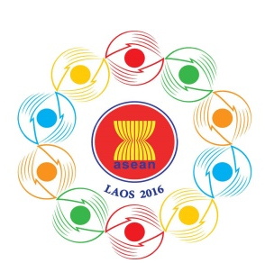
Turning Vision into Reality

for a Dynamic ASEAN Community
Laos 2016
‘Promoting Defence Cooperation for a Dynamic ASEAN Community’

ASEAN DEFENCE SENIOR OFFICIALS’ MEETING-PLUS
(ADSOM-Plus)
Lao Plaza Hotel, Vientiane, Lao PDR, 23-25 April 2016
Provisional Agenda

- Opening Remarks by the Chair
- Adoption of Agenda
- Report of Recent Developments in ASEAN (ASEAN Secretariat)
- Report of the ASEAN Defence Senior Officials’ Meeting-Plus Working Group (ADSOM-Plus WG) in Luang Prabang, 22-24 February 2016 by ADSOM-Plus WG Chair
- Exchange of Views on Regional and International Security and Defence Issues
- Progress Report of the ADMM-Plus Experts Working Groups (EWGs):
  - ADMM-Plus Experts’ Working Group (EWG) on Humanitarian Assistance and Disaster Relief (HADR) (Laos-Japan)
  - ADMM-Plus EWG on Military Medicine (MM) (Thailand-Russia)
  - ADMM-Plus EWG on Maritime Security (MS) (Brunei-New Zealand)
  - ADMM-Plus EWG on Counter Terrorism (CT) (Singapore-Australia)
  - ADMM-Plus EWG on Peacekeeping Operations (PKO) (Cambodia-Republic of Korea)
  - ADMM-Plus EWG on Humanitarian Mine Action (HMA) (Viet Nam-India)
- Consideration of the Co-Chairs of the ADMM-Plus EWGs in the 3rd Cycle (April 2017-April 2020)
- Other Matters
- Closing Remarks by the Chair

