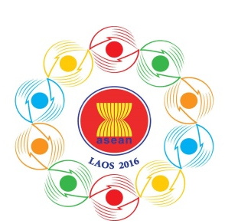
Turning Vision into Reality

for a Dynamic ASEAN Community
Laos 2016
‘Promoting Defence Cooperation for a Dynamic ASEAN Community’

ASEAN DEFENCE SENIOR OFFICIALS’ MEETING-PLUS (ADSOM-Plus)
Lao Plaza Hotel, Vientiane, Lao PDR
23-25 April 2016

Registration Form

Photo
4x6 cm

- Delegate’s Details
Country:
Head of Delegation (please tick) |  |  |  |  |  | Delegate (please tick)
Rank/Title:
Full Name:
Name on tag:
Passport No.:
Position:
Organisation:
Address:
Tel.: |  |  |  |  | Fax:
E-Mail:
Spouse accompanied  Yes No |  |  | If Yes, Spouse’s Full Name:  ………………………………………………………………………………………………….
2. Flight Details
Information |  |  |  | Arrival |  |  | Departure
Date
Time
Flight No.

3. Accommodation during the meeting

…………………………………………………………………………………………………………………
…………………………………………………………………………………………………………………

4. Dietary Requirements

Please detail any dietary requirements you may have:

………………………………………………………………………………………………………………………………………………………………………………………………………………………………

Kindly submit the completed registration form by 01 April 2016,
by fax or e-mail to the following contact:
10th ADMM Secretariat
Tel: + 856 21 911727
Fax: + 856 21 911728
E-Mail: admm2016laos@yahoo.com

- Capt. Maneelath Vongpakaiphet
Mob: + (856 20) 2248 2345
- Lt. Kosonh Bounleut
Mob: + (856 20) 5580 5678

