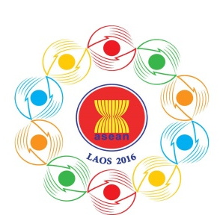

Turning Vision into Reality

for a Dynamic ASEAN Community
Laos 2016
‘Promoting Defence Cooperation for a Dynamic ASEAN Community’

10th ASEAN DEFENCE MINISTERS’ MEETING (10th ADMM)
National Convention Centre, Vientiane, Lao PDR
24-27 May 2016

Registration Form

Photo
4x6 cm

- COUNTRY:

- CATEGORY OF GUEST: (Please tick)

 | ADMM Leader (HOD) |  | ADMM Leader Spouse
 | ADSOM Leader |  | ADSOM Leader Spouse
 | ADSOM WG Leader |  | ADSOM WG Leader Spouse
 | Delegation member

- GUEST INFORMATION
Title / Rank:

Guest Name:

Name on tag:

Designation:

Ministry / Organisation /
Department:

Telephone / Fax:

Email:

- TRAVEL ITNERARY

Arrival | Date | Time | Flight No

Departure | Date | Time | Flight No

- ACCOMMODATION DURING THE MEETING

………………………………………………………………………………………… .
………………………………………………………………………………………… .

- DIETARY REQUIREMENTS

Please detail any dietary requirements you may have:

……………………………………………………………………………………………
………………………………………………………………………………………………..

Kindly submit the registration form by 01 May 2016,
either by fax or e-mail to the following contact:

10th ADMM Secretariat
Tel: +856 21 911727
Fax: +856 21 911728
E-Mail: admm2016laos@yahoo.com

