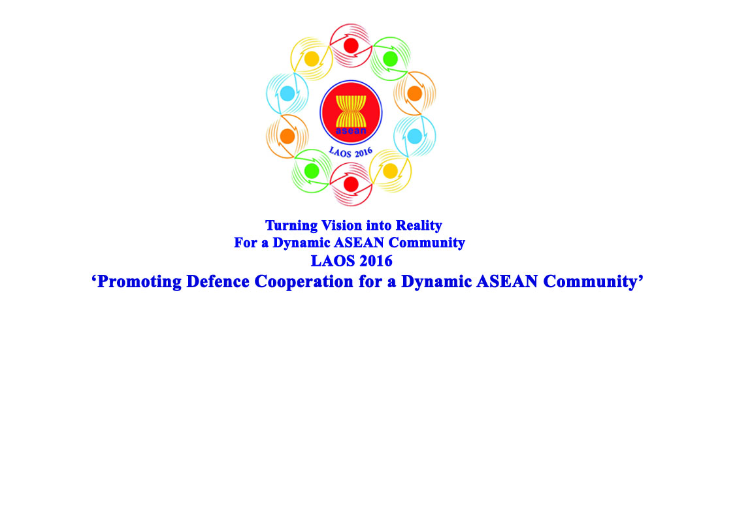

13TH ASEAN CHIEFS OF DEFENCE FORCES INFORMAL MEETING (13th ACDFIM)
13-15 March 2016
Vientiane, Lao PDR
SHIRT MEASUREMENT FORM
Please complete the shirt measurement below for administrative arrangement and submit it to the 13th AMIIM Secretariat by 25th January 2016.

A Collar
C E
G Chest

D H Waist
J I
Wrist B Hip

1. Country:
2. Name of HOD:
3. A --- B: Full Length of Shirt: ___________________________ cm
4. C --- E: Full Length of Shoulders: _______________________cm
5. C --- D: Full Length of Sleeves: _________________________cm
6. F: Full Round of Collar: ______________________________cm
7. G: Chest Width: cm
8. H: Waist Width: cm
9. I: Hip Width: cm
10. J: Wrist Width: cm

