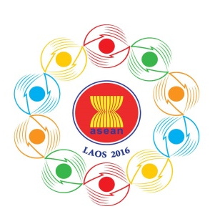
Turning Vision into Reality

for a Dynamic ASEAN Community
Laos 2016
‘Promoting Defence Cooperation for a Dynamic ASEAN Community’

ASEAN DEFENCE SENIOR OFFICIALS’ MEETING-PLUS
(ADSOM-Plus)
Lao Plaza Hotel, Vientiane, Lao PDR, 23-25 April 2016

Tentative Programme of Activities
Saturday, 23 April 2016

AM/PM | -  - | Arrival ADSOM-Plus Delegations  Bilateral Meetings
1730-1830 | - | Staff Meeting  Attendees : ADSOM-Plus WG Leaders and Delegates  Venue : (TBC)  Attire : Smart Casual
Sunday, 24 April 2016

0900- 1030 | - | ADSOM-Plus  Venue : (TBC)  Attire : Lounge Suit / Military Uniform
1030-1045 | -  - | Group Photo  Participants : Heads of Delegations  Coffee Break  Venue : (TBC)
1045-1200 | - | ADSOM-Plus
1200-1330 | - | Lunch  Venue : (TBC)
1330-1500 | - | ADSOM-Plus followed by Closing Session
1545-1630 | - | Call on Minister of National Defence, Lao PDR  Participants: Heads of Delegations  Venue : (TBC)  Attire : Lounge Suit / Military Uniform
1700-1830 | - | Free time / Bilateral Meetings
1900-2100 | - | Reception  Hosted by : Maj. Gen. Onesy SENESOUK, Permanent Secretary of the Ministry of National Defence, Lao ADSOM-PlUS Leader  Participants: All delegates  Venue : (TBC)  Attire : - HODs: Lao Traditional Shirt  - Other Delegates: Smart Casual / National Dress
Monday, 25 April 2016

AM/PM | - | Departure of Delegations

